Islay – May 2025 – Assignments (50 credits)

This assignment has 3 parts. The first part focuses on Snowball Earth. The second part focuses on some aspects of the geological carbon cycle. The sites referred to are described in the accompanying field guide. If time permits, we will also spend time exploring some cultural and historical sites on Islay.

Part 1- Snowball Earth

Snowball Earth refers to 2 periods of worldwide glaciation during the Cryogenian Period. These are the earlier Sturtian glaciation (716 – 658 Ma) and later Marinoan glaciation (645 – 635 Ma) (Hoffman et al., 2017).

According to proponents of the Snowball Earth hypothesis:

1. How did (a) the equatorial position of Rodinia and (b) orogenesis “set the stage” for global cooling and Snowball Earth? (2 credits)

(a) Equatorial position of Rodinia led to high albedo (there was no vegetation since it hadn’t developed yet, just a huge highly reflexive desert).
(b) Orogenesis provided “material” for chemical weathering, which is a cooling factor.

2. How would the geological carbon cycle be perturbed by a Snowball Earth and how would this perturbation affect Earth’s climate? (2 credits)

Weathering of rocks no longer happens (because rocks are under snow/ice) → accumulation of CO2 in the atmosphere
Separation of atmosphere from the ocean, so ocean cannot act as sink → accumulation of CO2 in the atmosphere
The accumulation of CO2 in the atmosphere reached 10%-30% and eventually led to very strong greenhouse effect which caused the Snowball Earth to start melting.

Rocks belonging to the Dalradian Supergroup which crop out on Islay were (probably) deposited before, during and after Sturtian glaciation.

- The Lossit Limestone Formation was deposited before Sturtian glaciation.
- The Port Askaig (Tillite) Formation was deposited during Sturtian glaciation.
- The Bonahaven (or Bunnahabhainn) Dolomite Formation was deposited after Sturtian glaciation.

Snowball Earth (if it happened at all) is probably represented by an unconformity at the base of the Port Askaig Formation.

We will visit the unconformity at the base of the Port Askaig Formations at Dunlossit (Locality 4.1), the Port Askaig Formation at Fionn-phort (Locality 5.1) and the Bonahaven Dolomite Formation near Bolsa on the northern shore of Islay (Locality 6.1).

3. Move the markers (by adding line breaks if you completing this task digitally) to mark the approximate stratigraphic positions of Bolsa, Fionn-phort and Bolsa. (3 credits).

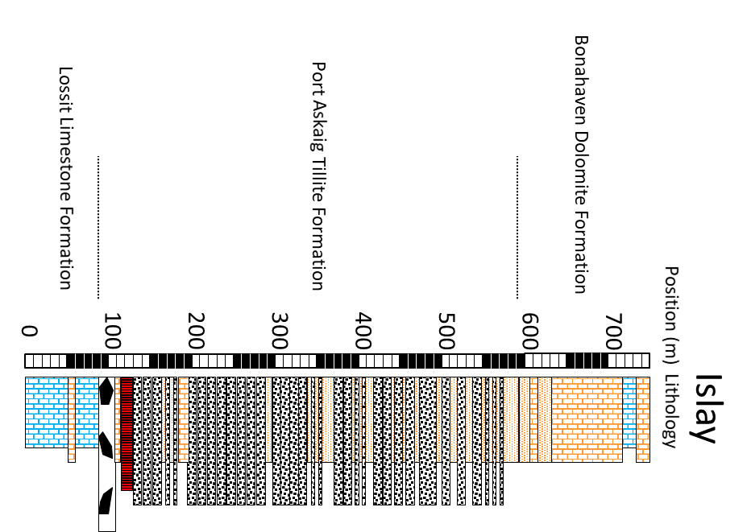 | ← Bolsa  ← Fionn-phort  ← Dunlossit

4. What paleoclimate indicator is found close to the top of the Lossit Limestone Formation at Dunlossit? (1 credit)

Layers of dolomite

5. How was it formed? (1 credit)

6. Which Köppen-Geiger climate zone (tropical, arid, warm temperature, cool temperate, polar) can be inferred from this paleoclimate indicator? (1 credit)

tropical

7. Make a field sketch to show the unconformity at the base of the Port Askaig Formation. Your field sketch should include labels and a scale bar. (4 credits)

8. What evidence of ice rafting can be found in the Port Askaig Formation at Dunlossit? (1 credit)

A drop stone

9. Interbedded beige-coloured dolostones and bluish-black-coloured sandstones which a high content of Fe-oxides crop out at Dunlossit. These could have been produced from clastic sediment which had been eroded from cap carbonates and iron formations. How might (a) cap carbonates and (b) iron formations have formed in the aftermath of Snowball Earth? (2 credits)

(a) A lot of carbon accumulated in the atmosphere during Snowball Earth. When the ice cap melted, it weathered into silica rocks, dissolved in the seawater, and precipitated as carbonate rocks at the bottom of the ocean. It is called “cap carbonate” to emphasise that it sits on top of non
(b) A lot of iron from the underwater volcanoes accumulated in the oceans during Snowball Earth. When the ice cap melted, oceans rapidly got oxidised again and precipitated iron.

10. Write down the percentages of different types of clasts in the Port Askaig Formation at (a) Dunlossit and (b) Fionn-phort. (4 credits)

Locality | Carbonates | Granites, amphibolites and gneisses | Others
Dunlossit
Fionn-phort | 86% | 14%
11. What can we learn from these data concerning glacial transport distances as a function of stratigraphic position? (2 credits)

In Dunlossit we can see much more local stones (dolostones), meaning the glaciers were moving slower and carrying rocks over shorter distances.
At Fionn-phort we counted much more foreign rocks and very few dolostones. This indicates that the glaciers were moving faster, over longer distances.

12. The same type of paleoclimate indicator which was found in the Lossit Limestone Formation near Dunlossit is also found in the Bonahaven Dolomite Formation near Bolsa. Make a field sketch to show one of them viewed either from the side or from above. Your field sketch should include labels and a scale bar. (4 credits)

13. What mineralogical paleoclimate indicator are pseudomorphed by (a) pinkish calcite and (b) pyrite, calcite and quartz in the Bonahaven Dolomite Formation near Bolsa. (2 credits)

(a)
(b)

14. Which Köppen-Geiger climate zone (tropical, arid, warm temperature, cool temperate, polar) can be inferred from these paleoclimate indicators? (1 credit)

arid

15. Write a 1-page essay (font type: Times New Roman; font size: 12; line-spacing: 1.5) in the space provided arguing for or against Snowball Earth based on field evidence from Islay. (10 credits)

The strongest argument for Snowball Earth to be found on Islay are the iron formations. For them to occur, the ocean must be completely separated from the atmosphere. Such conditions lead to buildup of iron content in oceanic waters (the iron originates from volcanic eruptions). Once the glaciers melt, oxygen from the atmosphere is introduced to the ocean and the iron precipitates into the formations we can observe at Dunlossit location.
Another indicator of Snowball Earth is the unconformity.

Part 2 – Some aspects of the Geological Carbon Cycle

In the slow (geological) carbon cycle, CO₂ is removed from the atmosphere as a side effect of the weathering of silicate rocks, carried as HCO₃²⁻ to the oceans by rivers, where it precipitates as carbonate rocks. Volcanism and metamorphism return this CO₂ to the atmosphere. The “turn around” time of this slow cycle ranges from hundreds of thousands to millions of years.

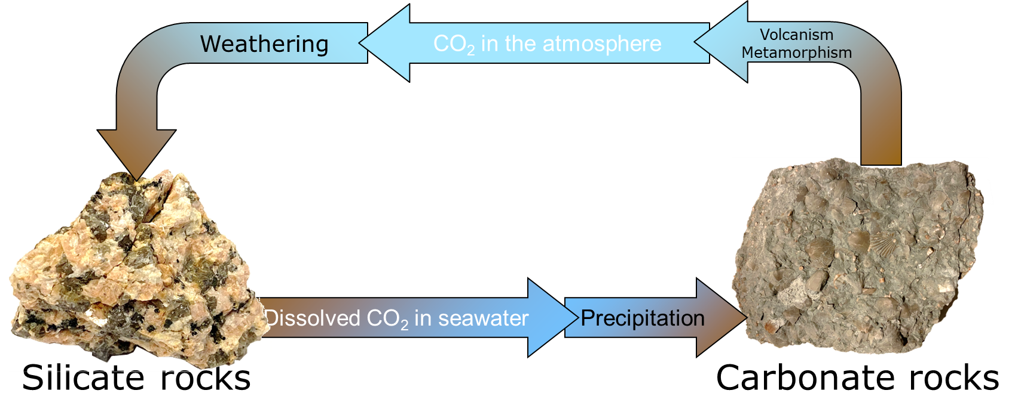
The Geological Carbon Cycle

On Islay, we will explore the role of metamorphism in the geological carbon cycle. If you would like to find out more, I have published a couple of papers which you might find helpful:
- Is orogenesis [mountain building] a net sink or source of atmospheric CO₂? (Geology Today 29, 102–107, 2013) – An easier read …
- Flux rates for water and carbon during greenschist facies metamorphism (Geology 29, 43–46, 2011) – The “nuts and bolts” …
These papers are included with this package.

Metamorphism is the process whereby rocks change to accommodate the extreme pressures and temperatures in the roots of mountain. During metamorphism, mudstone is transformed to various kinds of mica schists. These contain muscovite (white mica) and quartz as well as one or more of a variety of minerals. which include chlorite (green mica), biotite (brown mica) and garnet. During metamorphism, limestone is transformed to marble. Metamorphism of mixed mudstones and limestones releases water and carbon dioxide. These occur as a metamorphic fluid that escapes upwards by “eating” its way through rock.

Metamorphism of basalt (a volcanic rock) produces various kinds of metabasalt. One of them is called greenschist. It contains dark green amphibole and pale green epidote. These minerals react with water and carbon dioxide released by metamorphism of mudstones and limestones, forming chlorite (which contains water), calcite (which contains carbon dioxide) and quartz.

At Port Ellen (Locality 8.1), we will explore evidence of this reaction having occurred, and we will see how we can use this reaction to map out the movement of carbon dioxide through the roots of mountains on its way to the Earth’s surface where it leaks out into the atmosphere.

16. Make a sketch of the outcrop at Port Ellen. On your sketch, make sure to label:
- The layer of metabasalt (a sill),
- The underlying and overlying metamorphosed mudstones,
- the interior part of the sill that contains amphibole and epidote,
- the margins of the sill that contain chlorite, calcite and quartz
Also, make sure to include a scale bar. (5 credits)

17. Measure the width of the lower and upper sill margins that contain chlorite, calcite and quartz (2 credits).

Lower sill margin:
Upper sill margin:

18. What can we learn from these measurements about the direction in which metamorphic fluid was moving? Add an arrow to your sketch showing this direction (2 credit).

The direction of metamorphic fluid flow was partly upwards.
The direction of metamorphic fluid flow was nearly parallel to the sill.

19. These measurements have been used as a basis for estimating how fast carbon dioxide is added to the atmosphere by metamorphism caused by mountain building. How does this compare with how fast carbon dioxide is removed from the atmosphere by enhanced weathering caused by mountain building (1 credit).

During mountain building, metamorphism adds carbon dioxide to the atmosphere faster than carbon dioxide is removed from the atmosphere by enhanced weathering.

